How to Deploy Millions of COVID-19 Tests Per Day
An overview of existing technologies and the path to scaling to the millions of tests needed per day to get Americans back to work, prepared by Ginkgo Bioworks.

Executive Summary
There is broad agreement within the public health community that the path out of the COVID-19 lockdown is through widespread testing to catch new infections, tracing to find everyone who may have been infected, and supported isolation to prevent further spread of the virus. There is little agreement, however, that the technology and infrastructure exists today to meet that need.

With so much at stake—countless lives and billions of dollars—speed is of the essence in scaling up COVID-19 testing. This report provides an assessment of existing and emerging testing methods and outlines a path by which the United States can rapidly scale up the infrastructure that enables millions of tests per day.

To rapidly increase the scale of COVID-19 testing, the United States should:
- Continue to scale up testing methods already in use, such as RT-qPCR and other real-time molecular methods, by expanding the number of testing machines and kits.
- Leverage the country’s vast genomic sequencing capacity by repurposing it to dramatically augment testing capacity.
- Invest in the development of massively distributable, cheap point-of-use tests, such as antigen-based tests, and be prepared to deploy them as soon as they become available.
- Make testing widely available, beginning with those at highest risk, regardless of symptoms, insurance reimbursement, or other impediments.
- Scale up testing to enable screening of significant portions of the workforce and integrate screening effectively with contact tracing.

Contents
Testing levels needed to safely reopen the economy 4
Table 1: Epidemiological predictions of number of tests to safely reopen the economy 4
The technology to test millions already exists in the US 5
Table 2: Summary of different SARS-CoV-2 testing methods 7
How we can achieve millions of tests per day 8
Optimizing testing procedures for scale 10
Conclusion 12

Testing levels needed to safely reopen the economy
Until a vaccine is widely available, there is widespread agreement that large scale testing, tracing, and supported isolation is the only way to sustainably and safely reopen the economy. Public health experts have outlined reopening plans that rely heavily on testing, notably the Edmond J. Safra Center for Ethics at Harvard University’s Roadmap to Pandemic Resilience and the Rockefeller Foundation’s COVID-19 National Testing Plan.

- The Safra Center at Harvard estimates that nationwide we must deliver 5 million tests per day by early June to enable safe reopening. They estimate this number must increase, ideally by late July, to 20 million a day to fully remobilize the economy.

- The Rockefeller Foundation suggests that, from mid-April through mid-June, the country should be testing each week 3 million people—that is, one percent of the population. They project that testing at this level, combined with vigorous contact tracing, would allow crucial parts of the economy to have a limited restart. Within six months, they suggest that with intensive supply-chain oversight and roll-out of new testing paradigms should increase the testing level to 30 million people a week.

- Ashish Jha, Director of the Harvard Global Health Institute, believes that the ratio of positive tests to the total being performed in countries such as South Korea where the outbreak is under control is most relevant. Because screening dictates testing many healthy and infected but asymptomatic people, this ratio will be quite low. Countries where the virus has been more effectively contained have a ratio below 3%. Today, the United States averages above 20%.

- Others, including Dr. Paul Romer, focus on first stabilizing essential sectors while maintaining significant social distancing protocols and restrictions on non-essential businesses. According to the Department of Homeland Security, approximately 40% of the U.S. workforce performs essential services.

Table 1: Epidemiological predictions of number of tests needed to safely reopen the economy
Approximate number of tests needed per day in the United States
Ineffective  contact tracing¹ | Robust  contact tracing² | Extrapolation from low positive test ratio³ | Weekly testing of essential workers⁴
20 million | 4.3 million | 2.5–5 million | 9 million

The technology to test millions already exists in the US
The goal — identifying infections early to enable isolation and contact tracing — dictates which testing methods are most appropriate. The most pressing requirements are for tests that can be scaled up rapidly and sustainably and that possess a high level of diagnostic accuracy. No single method is the obvious best solution, but by leveraging all existing options in parallel we can successfully expand testing enough to contain the virus and end the pandemic.

Tests used for a test-trace-isolate strategy should detect the presence of the virus itself. Tests that detect antibodies against the virus present in a person's blood ("serology") indicate a past infection, and will be useful for epidemiological and immunity studies, but not for diagnosing active infections. Methods for identifying active infections either detect viral RNA (also called “nucleic acid tests”) or viral proteins (also called “antigen tests”). For both of these broad categories, different methods are used, each of which have distinct advantages, disadvantages, and paths to massive scale.


Figure 1 The virus has two main components, RNA (green) and protein (yellow, grey, red). Screening tests must detect the presence of either of these components to diagnose an active infection.

Image credit: Desiree Ho for the Innovative Genomics Institute.

Four main methods are used to detect the presence of viral RNA:
- Real-Time quantitative Polymerase Chain Reaction (RT-qPCR). Viral RNA is extracted from the sample and converted to DNA. The DNA is then amplified to enable its detection. RT-qPCR requires specialized machines that can cycle the sample temperature many times, allowing quantification of the viral load—useful for judging stage or severity of infection—as well as simple detection. This method is used by large clinical laboratories and is the method used for nearly all COVID-19 testing available today.
- Isothermal Nucleic Acid Amplification Technologies (iNAAT). There are several variants of RT-qPCR that are run at constant temperature, and thus require a somewhat simpler machine. These methods, including RPA (Recombinase Polymerase Amplification), LAMP (Loop-mediated isothermal AMPlification), TMA (Transcription Mediated-Amplification), and NEAR (Nicking Enzyme Amplification Reaction), are faster than RT-qPCR and can be performed in point-of-care devices, but they lose the ability to quantify viral load. Isothermal amplification is used in the Abbott ID NOW and Atila Bio desktop tests, and Hologic has just introduced a test for use in centralized laboratories.
- Next-Generation Sequencing (NGS). As in RT-qPCR, viral RNA is extracted, converted to DNA, and amplified. Detection occurs, however, by reading the RNA/DNA “genetic code” using genome sequencing machines. Designed originally for sequencing the huge human genome, NGS is able to process tens or even hundreds of thousands of samples in parallel on one machine, while retaining the ability to quantify viral load.There are approximately 400 NGS machines installed in the United States today that could be repurposed for diagnostics. Illumina, the Broad Institute, Hudson Alpha, the University of Washington, Octant, and others are all developing NGS protocols. Ginkgo Bioworks is developing NGS diagnostic methods in our Boston Seaport facility.
- CRISPR-based methods. These methods detect the viral RNA directly by using a bacterial protein that can be engineered to bind directly to viral RNA sequences. Various methods are used to amplify that binding to give a detectable signal. Leaders in this technology are the Broad Institute, Mammoth Biosciences, and Sherlock Biosciences.

Antigen tests, by way of contrast, use highly specific proteins called antibodies to bind viral antigens very tightly. The tests differ in how antibody–antigen binding is visualized:
- Enzyme-Linked ImmunoSorbent Assay (ELISA). The sample is applied to a plastic plate previously coated with an antigen-binding antibody. As with most RT-qPCR and all NGS tests, this method is performed in centralized lab facilities. Various reagent addition and washing steps are performed to produce a visible signal. ELISA is able to quantify viral load, as well as to give a diagnostic result.
- Lateral Flow Assay (LFA). LFAs operate by a principle very similar to ELISA, with the distinction that the binding antibody is coated onto a small membrane in a hand-held plastic cartridge—as in pregnancy test kits. Results typically appear within 15 minutes after sample application. Because of their quick speed to result as well as very low cost, LFAs are ideal for rapid “Point-of-Care” or “Point-of-Use” tests. Their key drawback is relatively low sensitivity, i.e. LFA tests fail to detect actual infections in more people than other methods.

Listed in Table 2 below are some of the key tradeoffs between these six leading and emerging testing methods. The methods are grouped by which viral component is detected, followed by accuracy, ability to scale, speed, and various other considerations.

Table 2: Summary of advantages and disadvantages of different SARS-CoV-2 testing methods

SARS-CoV-2 Testing Methods
Component Detected | Viral RNA |  |  |  | Viral Protein
Method | RT-qPCR | iNAAT | NGS | CRISPR | ELISA | LFA
Clinical  Accuracy | High | High | High | Medium | Unknown | Medium
Scalable to Meet US Needs? | Maybe | Maybe | Yes | Unknown | Unknown | Yes
Current US Tests/Day | ~200,000 | ~5,000 | 0 | 0 | 0 | Thousands
Projected Aug. 2020 Tests/Day | Hundreds of Thousands | Hundreds of Thousands | Millions | Unknown | Unknown | Hundreds of Thousands
Use  Case | High-volume  Centralized  or Point-of -Care | High-volume Centralized  or Point-of -Care | High-volume Centralized | Point-of-Use | High-volume Centralized | Point-of-Use
Turnaround  Time | 24-48 Hours (Centralized) | 24-48 Hours (Centralized) | 24–48  Hours | Minutes | 24–48  Hours | Minutes
 | Minutes (PoC) | Minutes (PoC)
Sample  Type | Nasal Swab  or Saliva | Nasal Swab | Nasal Swab  or Saliva | Nasal Swab | Unknown | Nasal Swab
Quantifies  Viral Load | Yes | No | Yes | No | Yes | No
Key Scale-Up Barrier | Reagent/Kit Availability | Reagent/Kit Availability | Logistics | Novel Technology | Assay Development | Assay Development
Regulatory Status | EUA | EUA | EUA pending | EUA | Unknown | EUA
Supply Chain Risk | Medium | High | Low | Medium | Medium | Low
Representative Companies | • LabCorp  • Quest  • Roche  • Thermo Fisher | • Abbott  • Hologic  • Atila Bio | • Broad Inst.  • Illumina  • Hudson Alpha  • Ginkgo | • Mammoth  • Sherlock  • Broad Inst. | • LabCorp  • Quest  • Abbott  • Roche | • Quidel  • ChemBio  • Cellex  • OraSure

Abbreviations: RT-qPCR, real-time quantitative polymerase chain reaction; iNAAT, isothermal nucleic acid amplification technologies; NGS, next-generation sequencing; CRISPR, clustered regularly interspaced short palindromic repeats; ELISA, enzyme-linked immunosorbent assay; LFA, lateral flow assay; PoC, Point of Care; EUA, Emergency Use Authorization.

How we can achieve millions of tests per day
There is no ideal technology solution that can alone meet the testing needs of our nation, but there are clear paths to massively increasing our testing capacity today.

Gold-standard RT-qPCR testing faces uncertainties in its potential to scale to more than a few times current levels given supply chain constraints, sampling methods, and throughput. Isothermal amplification methods such as those used by Abbott’s ID NOW test have high sensitivity and can be performed quickly at the point of care, but will likely face limitations at massive scale. Centralized testing facilities running NGS-based technologies can perform very accurate tests at massive scale, but the need for centralization can slow down turnaround time without significant automation and logistical effort. When ready to deploy, LFA antigen tests can be performed quickly at the point of use; CRISPR based tests hold massive promise but also are not ready for large-scale deployment.
Due to the immediate pressing need to increase the number of tests available, we recommend the following approach to build a portfolio of testing solutions for the nation:

1. Immediately scale up real-time molecular tests (RT-qPCR and isothermal variants) as much as possible

- RT-PCR is the current gold-standard method for SARS-CoV-2 diagnostics. It is widely available and has received FDA Emergency Use Authorization. A key weakness, however, will be the difficulty in scaling up the number of tests by the needed amount because scaling places ever greater demands on relatively weak supply chains. Significant effort is being made to scale up RT-qPCR testing, with reported goals of doubling capacity over the next month—to ~400,000 tests/day for the entire country. We should continue to scale up overall RT-qPCR testing capacity by a further 2X in the coming months.

- Likewise, isothermal amplification-based tests are today being performed at the point of care using devices such as the Abbott ID NOW machine. Uncertainties in ability to scale up remain for this method as well. We should work to increase the capacity of point-of-care iNAAT testing to the extent possible. This should include placing large orders of machines and kits to secure access to critical supply chains that are already in significant demand.

2. Immediately repurpose centralized genomics facilities for NGS testing at massive scale

- As noted in The White House’s recent Opening Up America Again testing blueprint, Next Generation Sequencing (NGS) represents a promising option to achieve the needed testing scale. The U.S. already has substantial NGS capacity and the projected capacity of NGS to scale up testing is unparalleled—using an approach called “multiplexing” that is unique to NGS, a single machine can, with the right processing methods, test as many as 750,000 individual samples daily. The sensitivity of NGS also meets or exceeds that of RT-qPCR. NGS has two important drawbacks. First, NGS is a centralized testing method, like large-scale RT-qPCR and ELISA, that requires a robust and rapid sample transport infrastructure and longer turnaround times than point of care options. Second, pre-analytical sample handling logistics at sequencing facilities requires more focused attention to enable massive scale. Though challenging, these are solvable engineering problems, not new technology issues. We should provide support to immediately repurpose centralized genomics facilities to enable NGS testing at massive scale.

3. Deploy LFA-based Point-of-Care/Use tests when they become available

- The White House Coronavirus Task Force recently highlighted antigen tests, in particular those that can be widely distributed and performed at the point of use, such as LFA tests. These cheap, hand-held devices are already used at massive scale at home (e.g. pregnancy tests) and in doctors’ offices (e.g. influenza tests). Current infrastructure supports the production of about a billion LFA devices/year, i.e. nearly 3 million/day, so scalability to meet COVID-19 demands is not an issue. Yet, the sensitivity of these tests is quite low relative to RT-qPCR, iNAAT, NGS, and ELISA (cf., point-of-care influenza tests), a characteristic that takes on special importance given the goal of detecting infections in asymptomatic or mildly ill individuals, in which viral loads may be lower. We should give LFA tests, especially those with improved sensitivity, high priority once they become available.

- CRISPR-based tests are emerging as potential screening modality that could also be run, in the future, with a hand-held device at the point of use. These tests promise improvements to the low sensitivity of point-of-care antigen tests, while retaining all of their advantages. CRISPR technology is in its infancy, however, and has not been proven at scale. We should give these tests high priority once they become available. CRISPR and LFA tests both received FDA EUA status in early May 2020.

Optimizing testing procedures for scale

In addition to the technical considerations necessary for scale, testing processes and policies must also be adapted to optimize for millions of people per day. Current testing across the country is for clinical diagnosis. In addition to scaling up clinical testing, suppressing the spread of the virus also requires population screening:

- Clinical diagnostic testing: Focus is confirmation of a COVID-19 diagnosis. Reserved for patients who meet certain criteria. Performed by trained personnel. Used to set the course of treatment in a healthcare setting.
- Population screening: Focus is finding infections before they spread. Widespread testing, including asymptomatic people. Needed to safely re-open the economy.

Population screening will require significant changes in who and how we test. Below are key factors needed to implement screening:

Screening Criteria
To identify infections before they spread, testing should focus on broad sampling of presumed healthy people—workers, college students, school children—rather than those who already exhibit symptoms of COVID-19. We should continue to focus on enabling testing services outside of clinical facilities. Accordingly, it is important that States, public health agencies, and the FDA continue making progress towards authorizing the regular testing of assumed healthy individuals.

Reimbursement
Population screening is only effective when testing is widespread. Every person in the country needs to be able to get tested without concern about payment or insurance pre-authorization. Changes in how tests are contracted and paid for are needed. Partnerships within the private sector and between the private sector and the government can help ensure that testing becomes best practice for businesses seeking to fully re-open.

Testing Procedure
Clinical tests are performed by nasopharyngeal swabbing, an uncomfortable procedure that requires trained personnel and the use of personal protective equipment (PPE). Screening tests ideally should be less invasive; for example, self-administered nasal swabbing. Recent evidence suggests that testing saliva can accurately diagnose infections, promising to make testing much more scalable. This type of technology should be available as an alternative to swabbing in the near term.

Technology
The testing methods used in population screening must satisfy two key criteria: scalability and high sensitivity. Most clinical tests use RT-qPCR. This method has high sensitivity and can be further scaled up, but to reach the testing numbers needed, other existing methods with greater scaling potential should also be leveraged. Some of these other methods, for example NGS, are nearly ready to be deployed but require investment and ecosystem support.

Logistics
Scalable logistics are needed for effective population screening. Many testing facilities today are not operating at full capacity because of bottlenecks in sample collection and delivery to centralized laboratory sites. Designing testing sites for scalability will be essential, with easy sample aggregation and straightforward delivery to laboratories. Testing kits should be designed to integrate seamlessly with laboratory automation; for example, sample tubes should be bar-coded rather than hand-labeled to enable robotic scanning and sorting.

Supply Chains
Critical short supply of FDA-approved machines, swabs, and reagents has plagued the scale-up of testing in recent months. Newer methods can bypass the need for certain supply chains (e.g. saliva testing vs. nasopharyngeal swabbing or protocols that eliminate the need for RNA extraction). Additionally, to truly scale our national testing infrastructure, we need coordinated effort to build manufacturing capacity for basic test collection equipment for a variety of testing modalities, including saliva collection tubes, nasal swabs, etc.

All of these changes will require close collaboration between regulatory agencies, businesses, scientists and clinicians across the US.

Conclusion

Effective and widespread testing paired with contact tracing is essential to safely reopen the economy. By leveraging existing technologies to run tests that are already available in centralized facilities, and by continuing to support innovation on broadly distributed tests, the U.S. can meet this challenge of testing millions of people daily, and thus safely reopen the economy.

In summary, the United States should:
- Scale up testing to millions of tests per day
- Make testing available to all individuals, beginning with those at highest risk, regardless of symptoms, ability to pay, or other impediments
- Deploy existing screening tests that can deliver at this massive scale
- Repurpose genomic sequencing facilities to rapidly augment testing capacity
- Deploy point-of-care tests, such as antigen-based tests, as they become available
- Encourage collaboration among and between the private sector and public health systems to facilitate contact tracing

The COVID-19 pandemic is an unprecedented challenge to our communities. The U.S. can rise to meet this challenge head on.

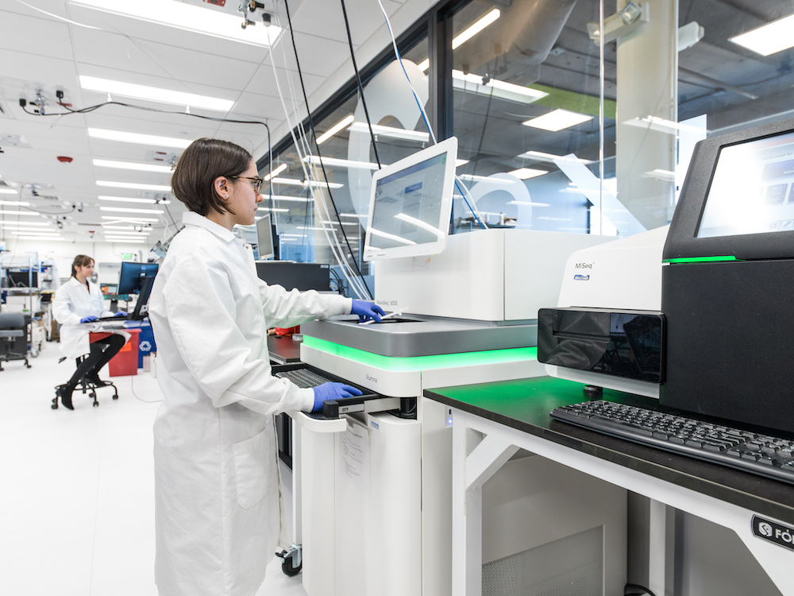

https://ethics.harvard.edu/files/center-for-ethics/files/roadmaptopandemicresilience_updated_4.20.20_0.pdf
https://www.statnews.com/2020/04/27/coronavirus-many-states-short-of-testing-levels-needed-for-safe-reopening/
https://www.cdc.gov/flu/professionals/diagnosis/clinician_guidance_ridt.htm
Dr. Deborah Brix on Meet the Press (Apr. 26, 2020) discussing the need for antigen tests: https://www.nbcnews.com/meet-the-press/meet-press-april-26-2020-n1192616
https://www.whitehouse.gov/wp-content/uploads/2020/04/Testing-Blueprint.pdf
https://paulromer.net/roadmap-to-reopen-america/
https://www.rockefellerfoundation.org/national-covid-19-testing-action-plan/
See this assessment of nucleic acid tests for more details https://interventions.centerofci.org/pub/covid-testing-assessment/release/14

